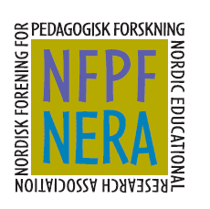
THE 6th ANNUAL NORDIC EDUCATIONAL CONVERSATION
Thursday October 23rd

AGENDA

14.00 – 14.05:
Welcome

14.05 – 14.20
Introduction by Birgit Schaffar-Kronqvist

14.20 – 15.00
Breakout room 1

15.00 – 15.05
A little break by Birgit Schaffar-Kronqvist

15.05 – 15.45
Breakroom 2

15.45 – 16.00
Plenum and goodbye.

